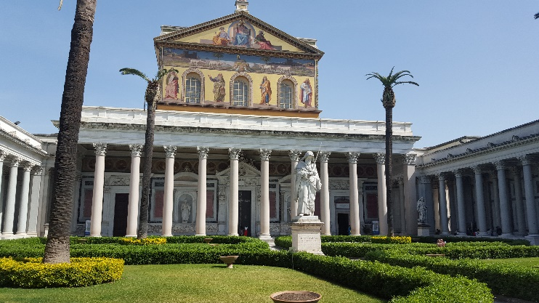Ah Rome, the eternal city. The place where the church consolidated its power and spread its wings. Our visit involved a trip to the catacombs, the Vatican and the three major basilicas within the city limits. Well one is outside actually.

The catacombs is not for the claustrophobic. At times passages narrowed to a width just a little beyond your shoulders. Contrary to popular belief it was not a place where the persecuted Christians hid to pray. It was really the burial chambers of the early Christians. Surface burial, or burial in tombs was too expensive, reserved for the wealthy.

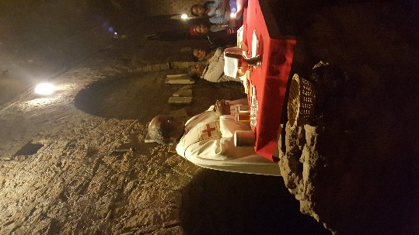The central feature of the catacombs was the gravesite of the saints. I had the distinct pleasure of celebrating mass there. Our tour guide took us to the site through narrow tunnels and then left quietly. I tried to memorize how many times we turned right and left, but gave up after a while. It was too complicated. He left us in this hallowed out cave, barely lit by bare bulbs. The bulbs cast dancing shadows everywhere but barely illuminated several more passages leading off in different directions. It was cool and totally silent. I had visions of us being forgotten by the guild and trying to find our way out through these passages. Maybe they will bury us here in these underground holes. Let’s hope the guy did not have dementia.

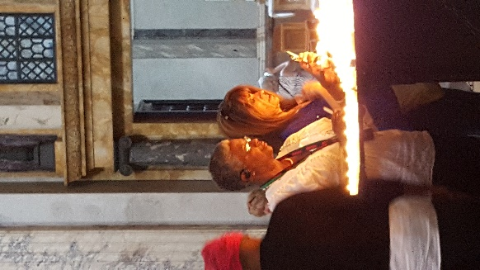My altar was a carved out stone, just barely bigger than the corporal, with two little kerosene lamps for illumination. Our voices echoed around the cavern as we reflected on those who had lost their lives for their faith. Many declined the tour which followed mass finding the narrow passages too much. Burial we learned was fairly simple in those days. The dead body was simply inserted into a niche dug into the side walls of the passage and the opening sealed up with plaster. What was amazing was the small size of people in those days. Most no more than five feet high.

A papal audience is not the sedate affair that the name suggest. You have to be in St Peter’s square by 7 a.m. to have any hope of getting a good seat. Good meaning the pope does not look like a little doll in the far distance. We positioned ourselves somewhere around the middle in one of the 30 or so lines. When the gates opened around 8 a.m. these 30 lines try to get through four gates positioned 50 yards away.

An hour or so later we emerged into the square squished, prodded, scanned and examined for metal objects. I now know how cows feel in the corral. But I suspect cows are much better behaved than us. The audience lasted some two hours. Pope Francis circled us and then made his way up to his throne and spoke for an hour or so. The rest of the time we heard greetings and prayers by various cardinals and bishops.

Mass in St Peter’s was a rushed affair. We were consigned to a side altar and instructed to finish mass in half an hour. The whole experience was a bit anticlimactic as Rome turned out to be more about art and architecture than anything else. But I suppose all that is part of the church.